Guide to accelerating applications with RISC-V custom instructions - Summary
Source: https://www.embedded.com/a-guide-to-accelerating-applications-with-just-right-risc-v-custom-instructions/
This article outlines the methodology for tailoring the RISC-V ISA to accelerate certain applications
Steps
- Select an application that is required to be accelerated on RISC-V
- Cross-compile the C/C++ based application using standard gnu cross compilercalled, riscv-gnu-toolchain.
- Execute the resulting binary code on a RISC-V Instruction Set Simulator such as riscv-isa-sim (a.k.a Spike)
- Through the process of profiling and analysis, instruction candidates are identified, designed and modelled as eleborated below:-
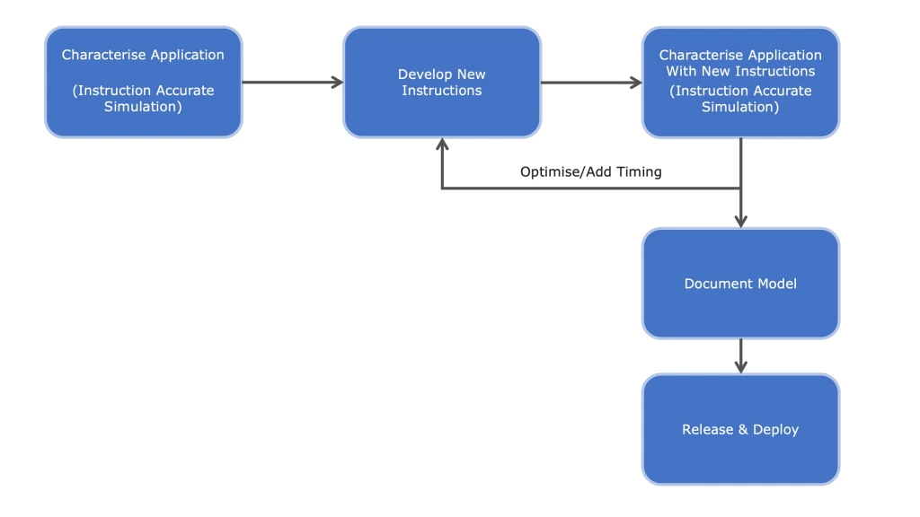
Figure 1: New instructions can be developed and evaluated in a simulation based upon the needs of existing application code.

- By reviewing the assembler code generated by the compiler and/or by running basic block profiling, it is then possible to determine which instructions and instruction combinations have been used to implement the algorithm.
- Determine what custom instructions, within the confines of the specifications of the ISA, could potentially increase execution speed.
- Without requiring the detailed hardware implementation of the RTL for these instructions, it is possible to simulate them in the ISS environment to see if they would be of any benefit at all to the challenge being faced.
- The four new instructions are modelled using the open virtual platforms (OVP) VMI application programming interface (API). (dunno these tools)
- This enables the developer to rapidly iterate the design of the instructions that provide the optimum desired outcome based on the new instructions for the target application. Only once this has been achieved is it necessary to commit resources to an RTL implementation.

Progress so far:
1. Installed riscv-gnu-toolchain and spike ISS.
2. Trained a 4-layer perceptron for MNIST
3. Coded the NN in C language and cross compiled onto RISC-V 64 bit processor. In order for SPIKE simulator to run, it requires a proxy kernel (riscv-pk) which is a code that builds an OS on the RISCV. The riscv binary is executed upon this proxy kernel.
4. Successfully executed the code on Spike
Plan for the coming week: Find out execution bottlenecks and frequently used sequence of instructions
1. Work on riscv-gprof (profiler tool) which provides staistics on code usage such as frequence of function calls, execution times. Currently, I’m not able to get riscv-gprof working (Some linker issues).
If unsuccessful , have to explore other tools for profiling, such as VAP toll mentioned in the article.
From KV sir...
1. Look for papers on Profiling
2. Look for functions that can accelerate NN computation such as conv, activations functions etc.,

